Thanh Phan u3175008

**Front End Web - Reflection Project 2**

**Index**

The final site is completely different from the sketch because while built the site followed from the sketches there was too much content on one page which will blurry the main content. The sidebar on the left-hand side of Index page has been removed as well as the tab reduced from 6 to 1. The reason for those to deliver the content to the users more efficiently.

**Hero Image in index page:** I used gif image to make the website look more life, instead of using normal png or jpg image.

**Content page (Description):** Look similar to the sketch, the only thing changed is 2 columns of the paragraph was combined into 1. Because the description of each place was too short and won’t look nice if we split it into 2 columns, cause of that the images moved up to the same row of the paragraph to make it look nicer and easy for the users to catch the main content.

**The font was used in the site:**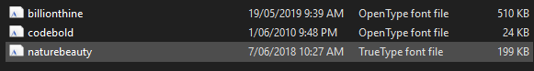

**Colour and themes:** were stayed the same as the sketch.

**Problems faced while building the site**

Forgot to put the reset file before started the project, then a few messes up everywhere.

CSS goes from top to bottom, example if we build laptop view first then mobile view laptop view will show as mobile view. So, remember to star with the small pixel first.

I have built the view for each breakpoint, and the site only shows up as the design if it is the range I have settled up. If anything, go below or over, it won’t show up as the designed. “There is no way to cater to every possible screen size unless we build designs that can respond to whatever device they’re used with.” (Ben_Uc_Winter1029)

**Below is the look of Index Page in size 1920 x 1080 (my laptop size), and this design will be the same/similar with the tablet view (size of the tablet is between 768 to 999px) and normal laptop size 1024px.**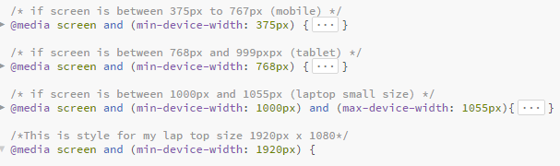

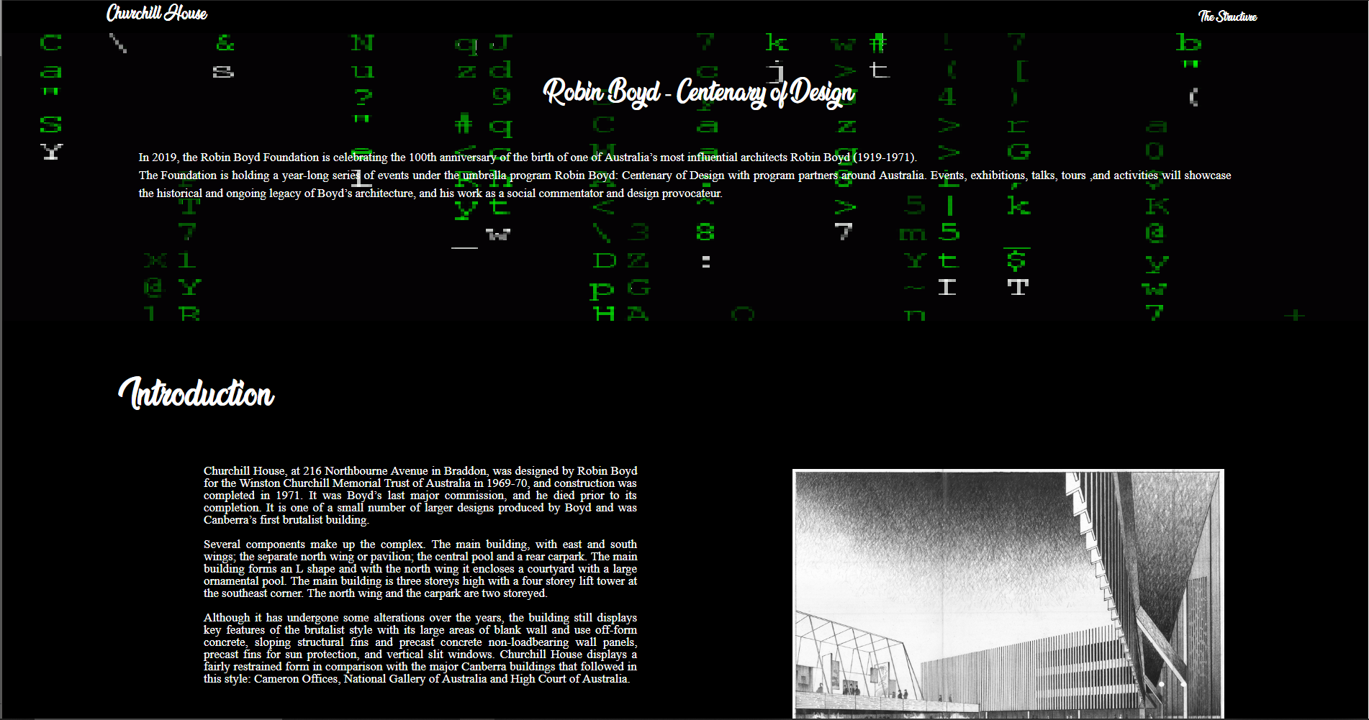

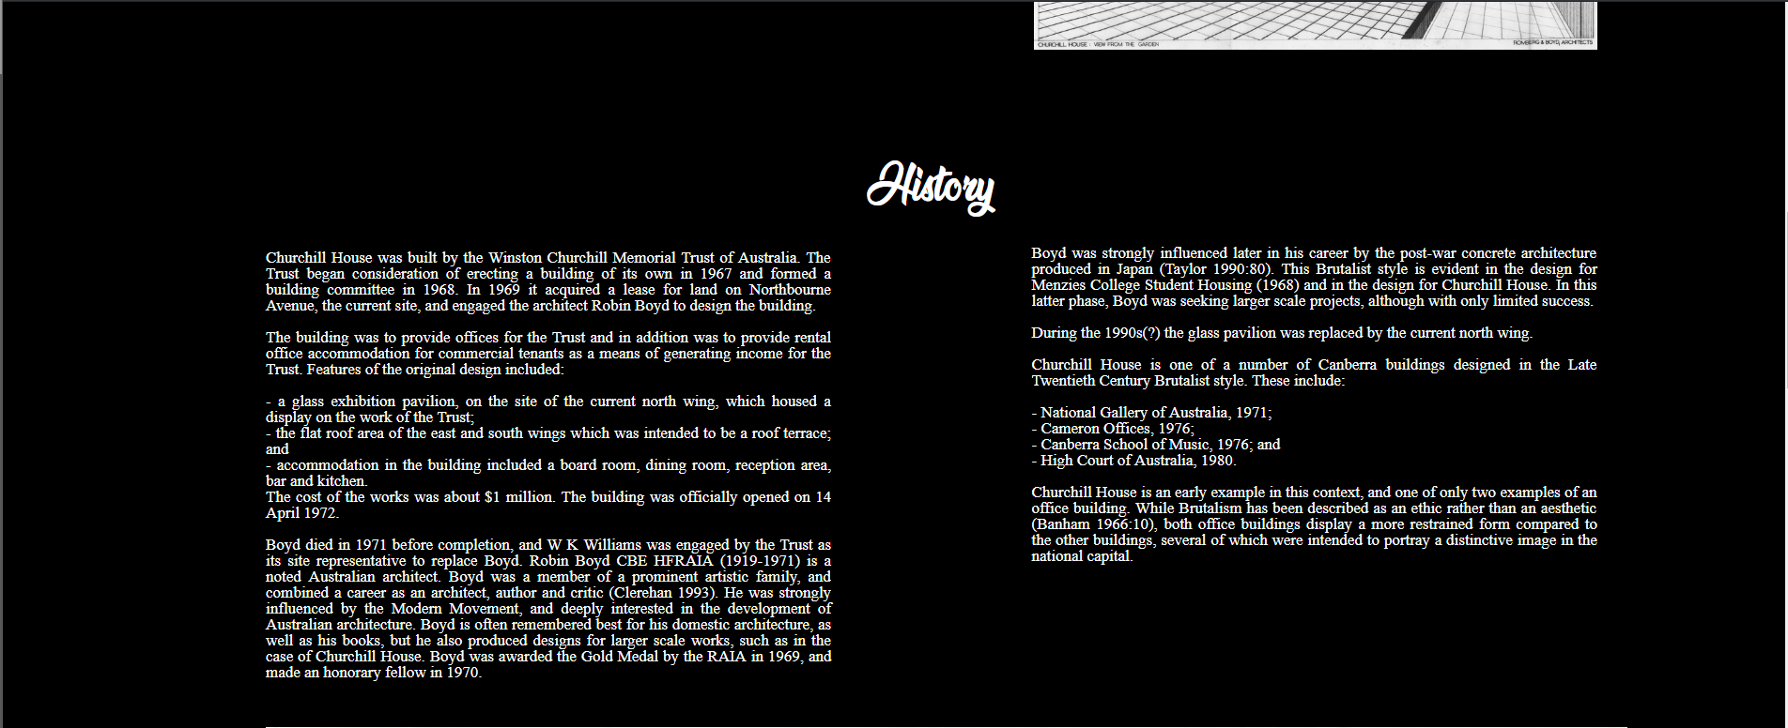

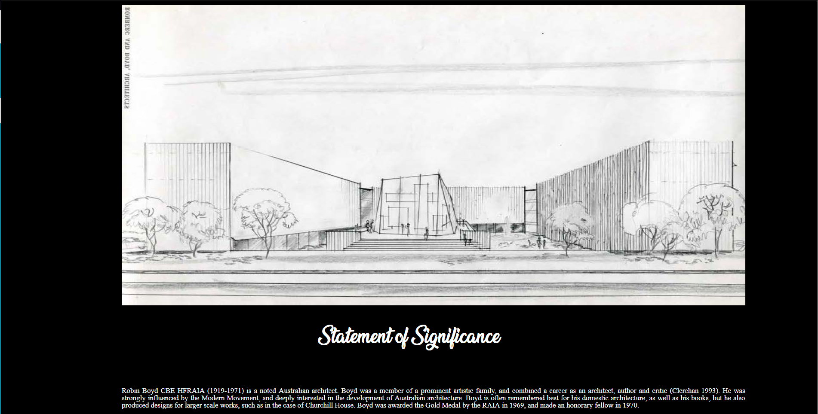

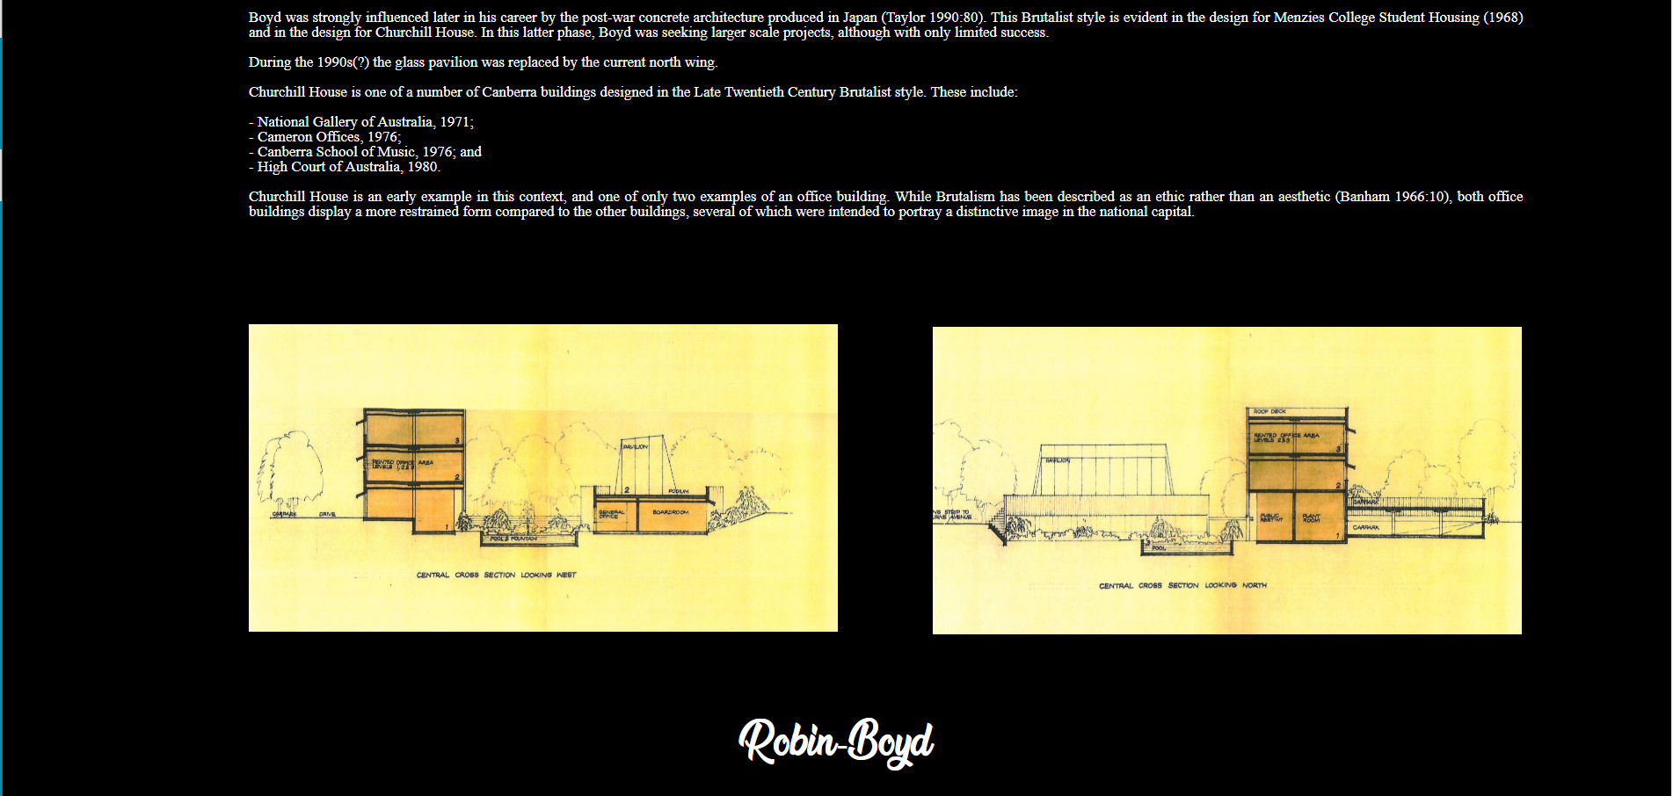

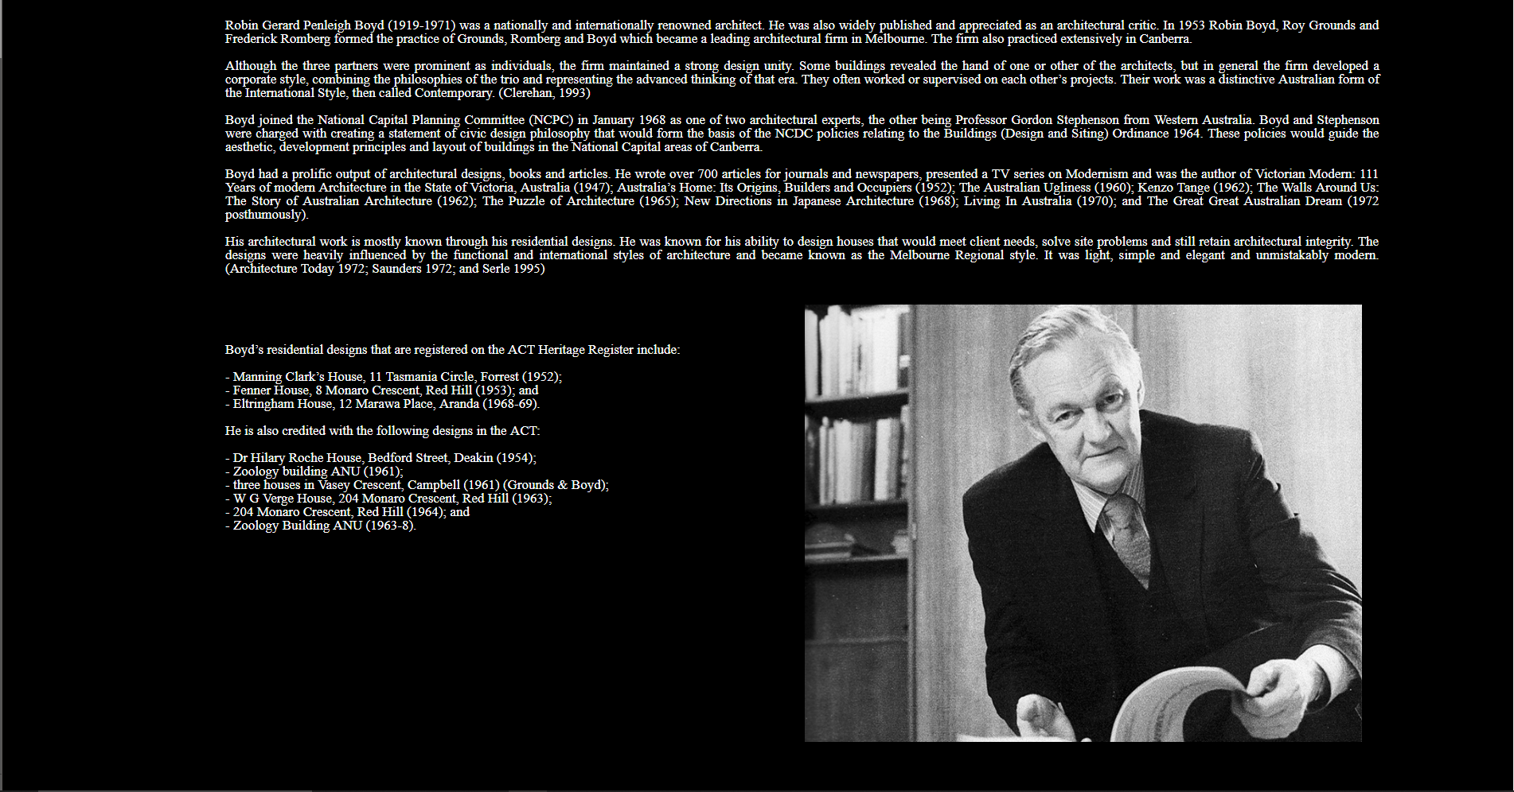

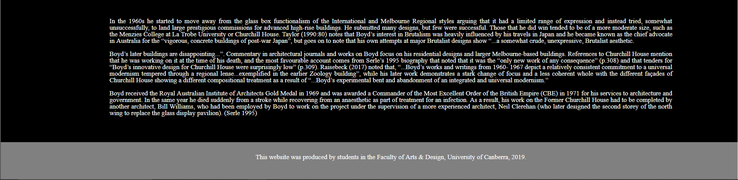

**Index page in Mobile size view 375px to 767px if over 767px the layout will be the same as above picture.**

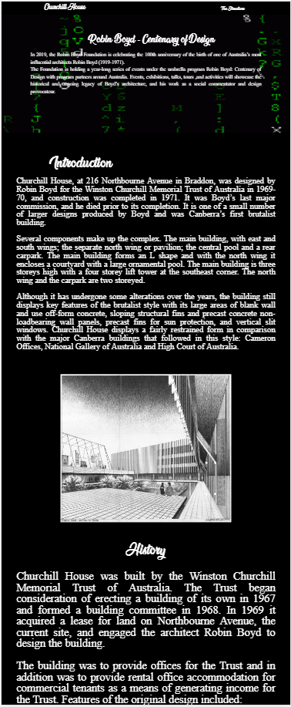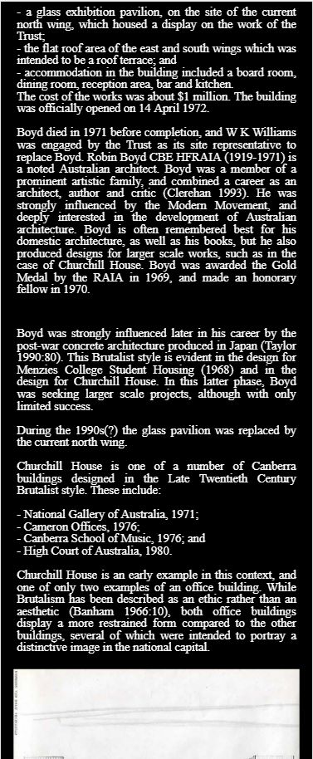

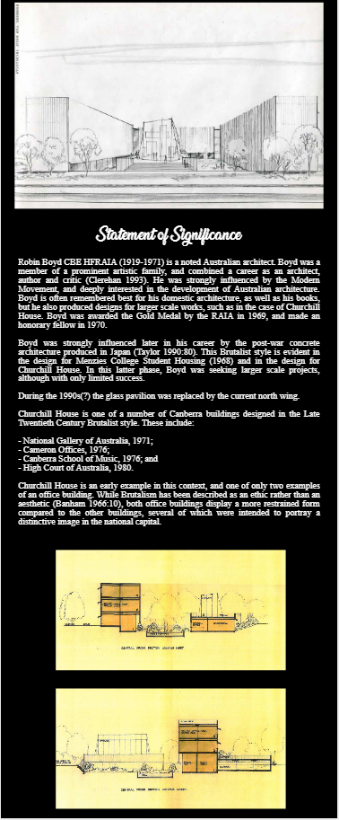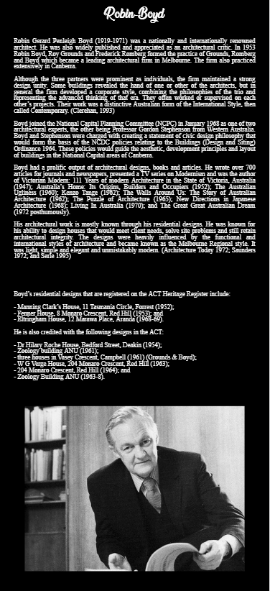

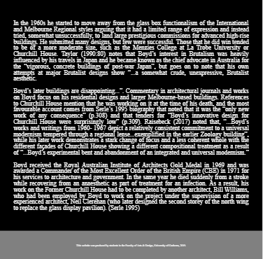

**Description page look on my laptop 1920px x 1080px**

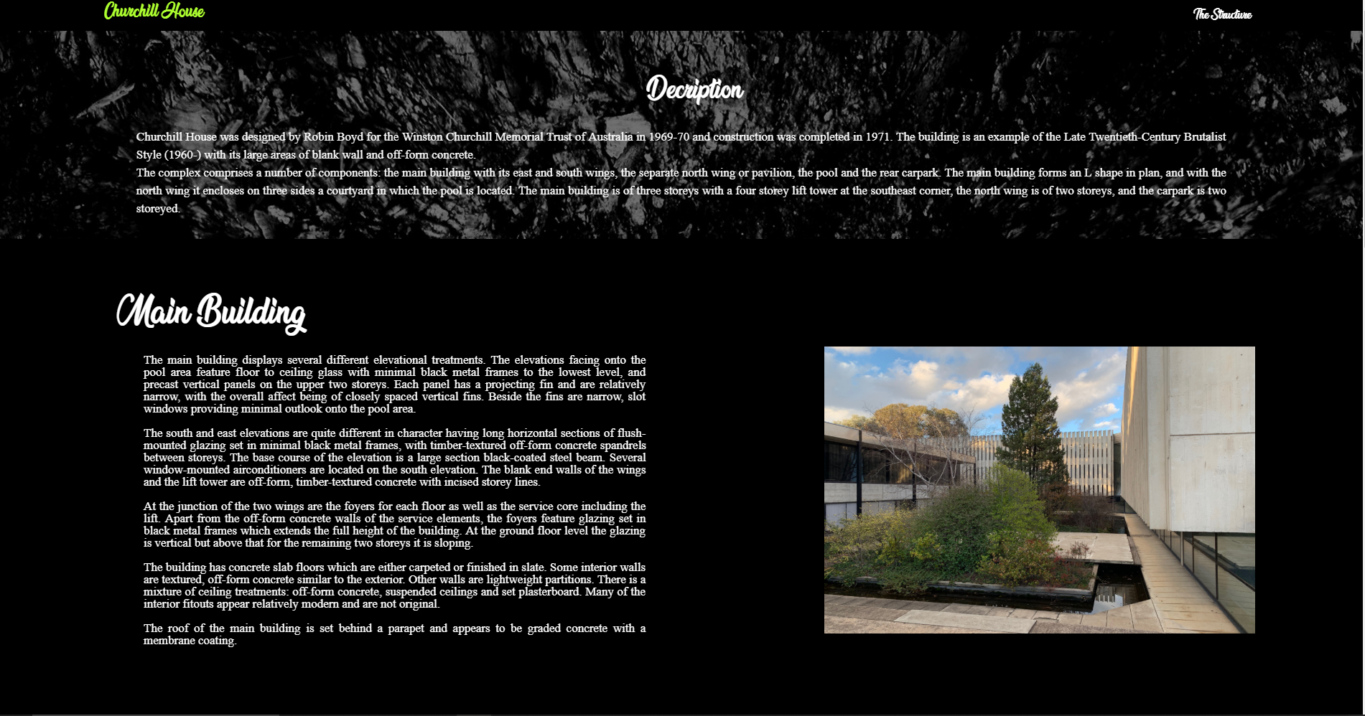

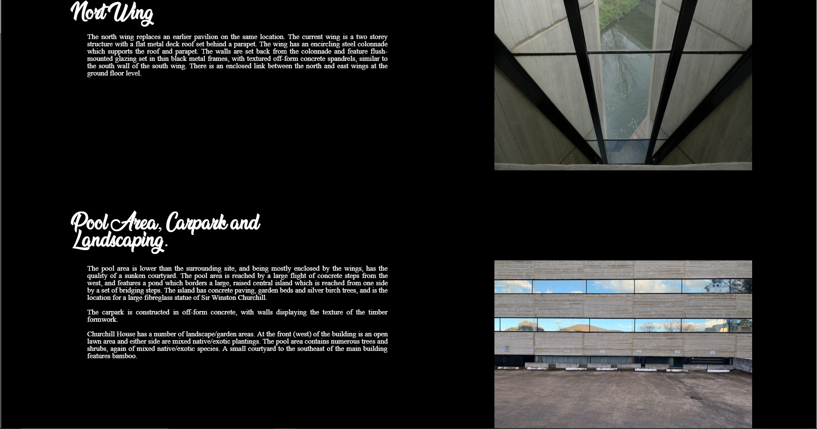

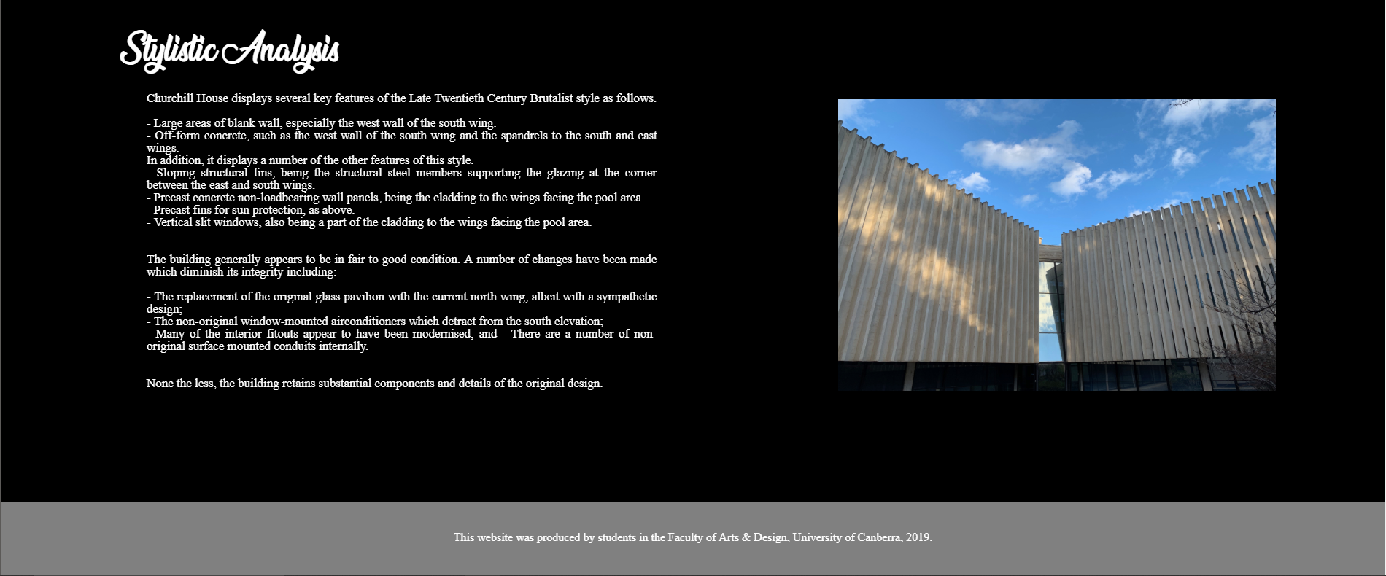

**Mobile, Tablet, and Laptop will display the same layout but the content will be getting bigger and more space when the pixel is increased. The pixel will start from 375 to 1024 if anything below or over that number the content will start moving around by itself. And the content won’t remain the same layout designed in the sketch.**

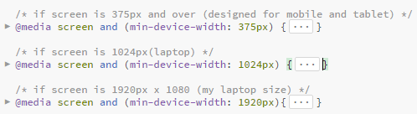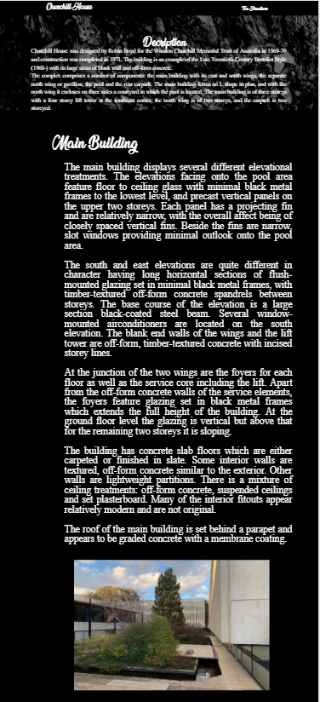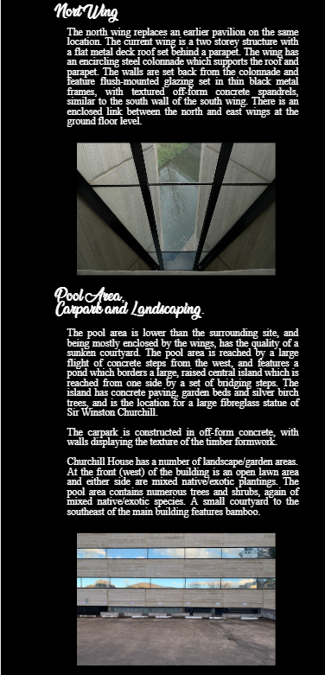

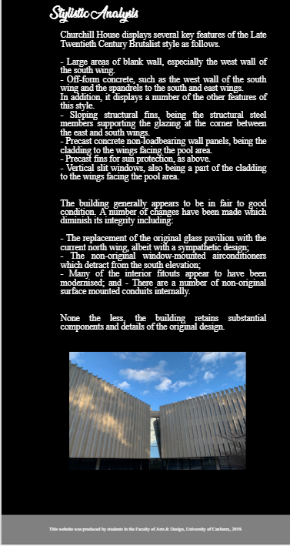

Reference of out-sourcing images:

Index page: <https://gfycat.com/deadlygleefulkronosaurus-matrix-movie>

Description page: <https://depositphotos.com/143998643/stock-photo-black-marble-background-stone-texture.html>